Module: Adaptive Systems
CandNo: 231914

Title: Adaptive Multi-agent Systems: An Analysis of Boids Simulation Using Q-Learning

Abstract
This paper explores the concept of adaptivity and self-adaptivity within the context of multi-agent systems, specifically focusing on a simulation of a flock of birds, known as 'boids'. These boids demonstrate adaptivity through their ability to learn and modify their behaviors based on their experiences within their environment. This learning process employs a reinforcement learning approach, more specifically, a Q-learning algorithm, which allows each boid to learn the optimal action to undertake in different states. The adaptivity of the boids system is thus characterized by its capacity to learn from its environment, iteratively refine its actions, and maximize its rewards, culminating in increasingly successful and intelligent behaviors over time.

Introduction

An adaptive system constitutes elements or agents that can adjust and respond to changes in their environment. They are capable of learning from their experiences and altering their behavior accordingly through a feedback meachanism, which leads to the evolution of the system over time. This adaptability is a key feature of self-organizing systems. Adaptivity or self-adaptivity in the context of the system described in our system refers to the ability of the boid agents to learn and adjust their behaviors based on their experiences in the environment. Each boid agent uses a reinforcement learning approach, specifically a Q-learning algorithm, to learn the optimal action to take in different states. Therefore, the self-adaptivity of the system lies in its ability to learn from its environment and iteratively refine its actions to maximize its rewards, leading to more successful and intelligent behaviors over time (Hartnan and Benes, 2006).

In 1986, Craig Reynolds pioneered a computer model to emulate the coordinated motion of animals such as bird flocks and fish schools. This model, referred to as "Boids," was constructed using the three-dimensional computational geometry that is commonly utilized in computer animation or computer-aided design. The model outlines three fundamental steering behaviors that dictate how an individual "boid" navigates based on the positions and velocities of its nearby flockmates. These behaviors are separation, where a boid maneuvers to avoid crowding its local flockmates; alignment, where a boid maneuvers to match the average direction of its local flockmates; and cohesion, where a boid maneuvers towards the average position of its local flockmates. By integrating these three fundamental principles, a unified, collision-free movement pattern amongst all boids in a formation can be achieved (Reynolds, 1987 as cited in Tanner, Jadbabaie and Pappas, 2003).

In this study, the boids system is analyzed using local, not global, information. This means that each individual agent, or boid, makes decisions based on immediate feedback received from the environment and learns from these experiences, rather than having full knowledge of the entire system. The region of influence for each boid, often referred to as the 'neighborhood', is defined by a spatial radius and an angular measure, and only those flockmates that fall within this neighborhood contribute to the boid's decision-making process. This neighborhood serves as a representation of the boid's limited perceptual capability and defines the spatial zone within which the boid's steering maneuvers are influenced by proximal flockmates (Reynolds, 1995).
The research is grounded on the hypothesis that boids, through reinforcement learning, can effectively learn to navigate within a flock. An increase in Q-values over time for actions that lead to desirable outcomes, such as maintaining proximity to the flock and avoiding collisions, is anticipated. Conversely, a decrease in Q-values for actions resulting in undesirable outcomes is expected. This pattern would suggest that the boids are learning to select actions that yield higher rewards through their interactions with their environment, providing evidence of their adaptivity (Gulzar et al., 2021)
The aim of this research is to provide insights into the degree of adaptivity in boid agents at an individual level. Through a detailed analysis of their behaviors and learning processes, it contributes to a better understanding of multi-agent systems and their potential applications. Further this paper hopes to understand to what extend would the hypothesis support the behavioural results of the boids system (Tanner, Jadbabaie and Pappas, 2003, p.1-2).

Methodology

Problem Formulation
The program simulates a flock of boids using reinforcement learning: Q-learning which is a an off-policy algorithm, which means it learns the value of an action in a particular state under a greedy policy, regardless of the agent's current policy. The central part of the Q-Learning algorithm is the Q-Learning update rule. It uses the Bellman Equation to iteratively update the Q-Values in the table and converge to the optimal action-value function. . The problem formulation of Bellman’s equation used in this simulation is set up as shown in Eq 1 (Kim and Yang, 2020):

Assuming the weights for 'separation', 'alignment', and 'cohesion' are represented by , and respectively. The updated equation for the simulation would be shown as in Eq 2:

- represents the state for separation.
- represents the state for alignment.
- represents the state for cohesion.
- , and represent the weights for 'separation', 'alignment', and 'cohesion' respectively.
- represents the next state after taking action in the current state
- The term max calculates the maximum value among the Q-values for the three actions in the next state .

In this equation (Eq2), the expected future reward is a weighted sum of the Q-values for the three actions in the next state where the weights are the importance weights for each action.

The process of Q-Learning involves the agent exploring the environment, and based on the state it's in and the action it takes, it updates the Q-Value of that state-action pair in the Q-Table. This update is done considering the maximum Q-Value of the new state’s'. This process is repeated many times for each state-action pair until the Q-Values eventually converge to an optimal action-value function, where the Q-Values represent the expected future reward of a state-action pair.

In the Eq 1, the (1 - α) is a factor that determines the influence of the new information on the updated Q-value. It scales the old Q-value, so if α is 1, the old Q-value will be completely replaced by the new information. If α is 0, the old Q-value remains unchanged. Values of α between 0 and 1 allow for a balance between the old Q-value and the new information.

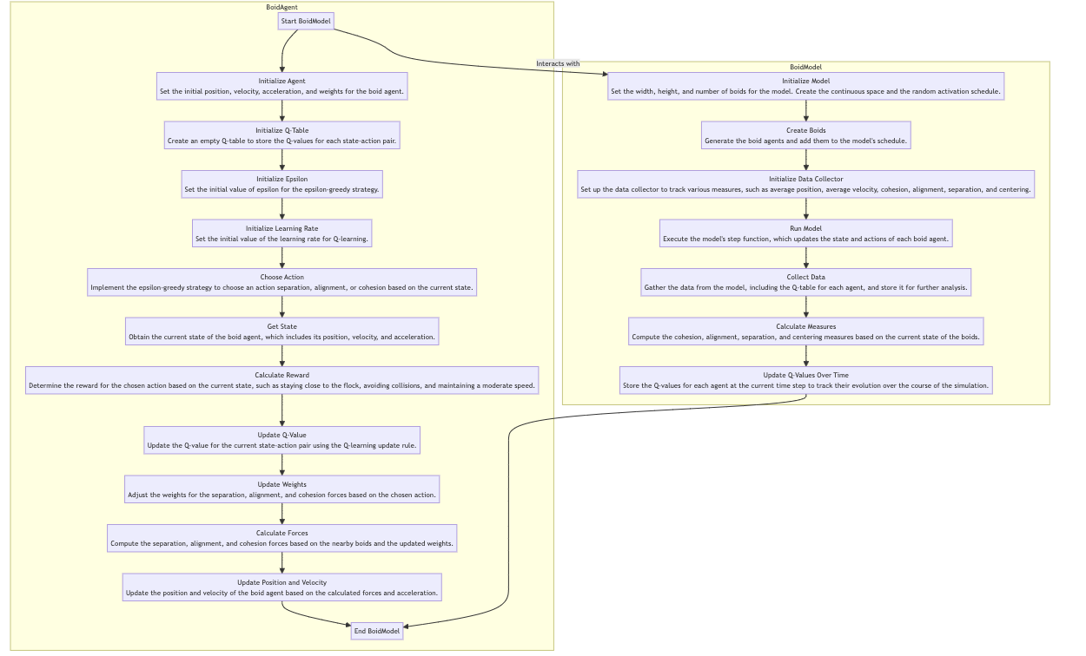
Fig 1. Flowchart of the Boid system. The system divided into 2 classes: BoidAgent and BoidModel
The state of each boid, referred to as the State Space (S), is defined by its position, velocity, and acceleration. Each of these parameters is a 2D vector, making the state space a 6D space. The actions that a boid can undertake, known as the Action Space (A), are 'separation', 'alignment', and 'cohesion'. These actions represent different behaviors that the boid can display. The Transition Model (T) is defined by the step method in the Boid class. This method is responsible for updating the boid's state based on its current state and the action it decides to execute. The Reward Function (R) is defined by the reward method in the Boid class. This function calculates a reward based on the current state and the action taken. The boid is rewarded for staying close to the flock, aligning its velocity with the flock, and choosing the 'alignment' and 'cohesion' actions. Conversely, the boid is penalized for being too far from the flock, colliding with other boids, and choosing the 'separation' action. The Policy (π) is defined by the choose action method in the Boid class. This method implements an epsilon-greedy strategy, where the boid randomly chooses an action with a probability epsilon, and otherwise, it opts for the action with the highest Q-value. The Q-values are stored in a dictionary for each Boid object. These Q-values are updated in the update q value method using the standard Q-learning update rule.The main objective of the simulation is to learn a policy that maximizes the total reward over time, leading to the flock exhibiting realistic flocking behavior (Olfati-Saber, 2006).
Individual Boid Simulation: Position, Velocity, and Learning Behavior
The BoidAgent class simulates flocking behaviour on an individual level. Each boid is given a unique ID, position, velocity, acceleration, and weights, which contribute to the three main behaviors: separation, alignment, and cohesion. The boid uses a Q-learning algorithm to learn the optimal behavior. This algorithm involves a table of Q-values, representing the expected future reward for each potential action in a certain state. The boid makes decisions based on a strategy that balances the exploration of new actions with the exploitation of known good actions. This strategy also includes updating the Q-value for a specific pair of state-action, based on the reward and the maximum Q-value of the new state. The current state of the boid can be fetched and the reward for a specific pair of state-action can be calculated. The weights can be updated based on the chosen action. One time step of the simulation can be executed, which includes choosing an action, updating the Q-value, and updating the position and velocity. The respective forces based on the positions and velocities of nearby boids can be calculated.

Flock Management: Environment Representation and Data Collection
The BoidModel class representing the entire flock of boids creates a continuous 2D space to emulate the agent- based environment and uses a random activation schedule, updating the boids in a random order. The model also collects data on the average position and velocity of the boids. It initializes the model with a given width, height, and number of boids, including the space, schedule, and data collector.
Furthermore, it executes one time step of the simulation, updating the boids and collecting data. It begins by collecting data about the current state of the model, including metrics like the average position and velocity of all the boids. Then, it activates the method for each individual boid in the model. This method updates each boid's state based on its current position, velocity, acceleration, and the steering forces acting on it.
Subsequently, it updates the list that maintains the Q-table for each boid at each time step - a Q-table being a structure that stores the expected future rewards for all possible actions in each possible state. Lastly, it collects all the unique states from all the boids in the simulation. This comprehensive process allows the simulation to capture a detailed snapshot of the boid flock dynamics at each time step. After data collection, the simulation is ran for a specific number of steps and then prints out the Q-values for each boid.
Additionally, the Boid simulation model is implemented in Python using the Mesa library. Mesa is an agent-based modeling framework in Python that serves as the counterpart to NetLogo, Repast, or MASON. It enables the simulation of actions and interactions of autonomous agents in a network or any other computational environment. With Mesa, users can quickly create agent-based models using built-in core components, such as spatial grids and agent schedulers, or customized implementations. The models can be visualized using a browser-based interface and analyzed using Python’s data analysis tools. Agent-based modeling allows for modeling the dynamics of complex systems and environments, where each agent individually assesses its situation and makes decisions based on a set of rules (Kazil, Masad and Crooks, 2020).
The Boid simulation was written and executed in PyCharm, a widely utilized integrated development environment (IDE) for Python programming.

Reinforcement learning process
In the boid system, Q-learning algorithm optimizes the navigation behavior within a flock of birds by harmoniously orchestrating three primary behaviors: separation, alignment, and cohesion. Separation behavior prevents overcrowding by ensuring each bird maintains an appropriate distance from its neighbors. Simultaneously, alignment behavior adjusts a bird's direction and speed to match that of its neighboring birds, creating a sense of unity and direction within the flock. Cohesion behavior further strengthens this unity, encouraging each bird to stay close to the flock by moving towards the average position of its neighbors. As the bird interacts with its environment, it receives rewards or penalties based on these behaviors, which it uses to update its Q-table. This table serves as a knowledge base storing the expected future rewards for all possible actions in each possible state. The continuous learning and updating process allow the bird to gradually understand the most beneficial actions under different circumstances, thereby developing optimal behavior within the flock.

Results & Analyses
The simulation used a total of 200 episodes as indicated by the variable num_episodes = 200. Each episode signifies a complete run of the simulation from the beginning to the end, with the simulation being initialized at the start of each episode. Within every episode, the simulation is run for 50 steps. Each step represents an iteration of the simulation where each agent in the model takes an action based on its current state, and the state of the model is subsequently updated. Hence, in total, the simulation is run for 200 * 50 = 10,000 iterations.
In the simulation, several other parameters were set that is thought have an effect on the learning behaviour of the agent of the system. The epsilon value, which dictates the degree to which the agent explores its environment, was initially established as 1.0, implying that the agent takes random actions initially. As the simulation progresses, the epsilon value is progressively reduced at a rate of 0.995 per step, as determined by epsilon decay, down to a minimum value of 0.01, as determined by epsilon min. When the epsilon value reaches this minimum, the agent starts to behave more greedily, choosing the action it believes has the highest Q-value. The learning. rate was set to 0.5. This rate allows the agent to strike a balance between learning from the new reward and the old Q-value. The discount factor is another parameter that was set to 0.95, and it represents the extent to which the agent takes into account future rewards. A discount factor of 0.95 means that the agent places nearly as much value on future rewards as it does on immediate ones. The weights for separation, alignment, and cohesion were initially set as an array [1.0, 1.0, 1.0], indicating that all three behaviors were given equal consideration at the start of the simulation.

The results of the study revealed interesting insights into the behavior and learning process of the boids b analysing the "Average Q-values Per Episode" and "Average Q-value Over Time" graphs, which showed the evolution of expected future rewards or Q-values for certain actions in certain states. Finally, the "Distribution of Q-values" graph provided insight into the learning progress of the agent.

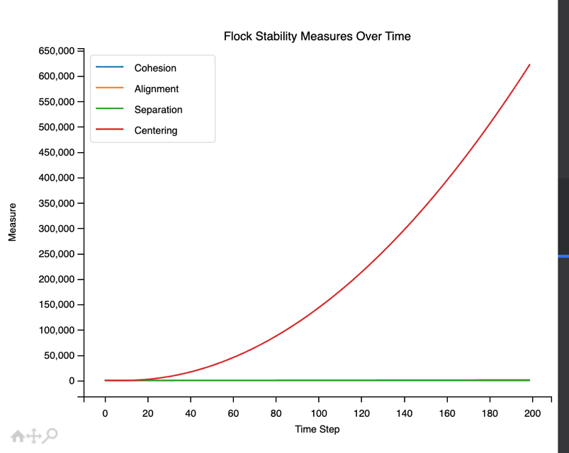
Fig 2. Plot of Flock stability measures over time for four rules of the boid system: Cohesion, alignment, separation and centering.

The “Centering" measure, shown in Fig2., is the only one that is increasing over time while the other measures ("Cohesion", "Alignment", "Separation") remain constant (horizontal straight line), it suggests that the boids are moving away from the center of the flock over time. This could be due to a variety of factors, such as the initial conditions, the parameters of the model, or the behaviors of the boids. The increasing "Centering" measure indicates that the flock is becoming less centered, which could be a sign of instability. The boids might be dispersing or moving in different directions, leading to a larger variance in their positions. And this might happen during the when boids are exploring a large space.
This result can be analyzed with respect to four metrics used to evaluate the stability of the flock: Cohesion, Alignment, Separation, and Centering. Cohesion measures the average distance between each boid and every other boid, with a lower value indicating a more cohesive flock. Alignment measures the variance of the velocities of all the boids, with a lower value indicating a more aligned flock. Separation measures the minimum distance between any two boids, with a higher value indicating a more separated flock. Lastly, Centering measures the variance of the positions of all the boids, with a lower value indicating a more centered flock.If the values of Cohesion, Alignment, and Centering are low and the value of Separation is high, the flock is considered stable. However, in our case, the increasing Centering value over time, coupled with constant Cohesion, Alignment, and Separation values, suggests periods of instability where the boids are possibly spreading out, moving in different directions, getting too close to each other, and straying from the center of the flock.
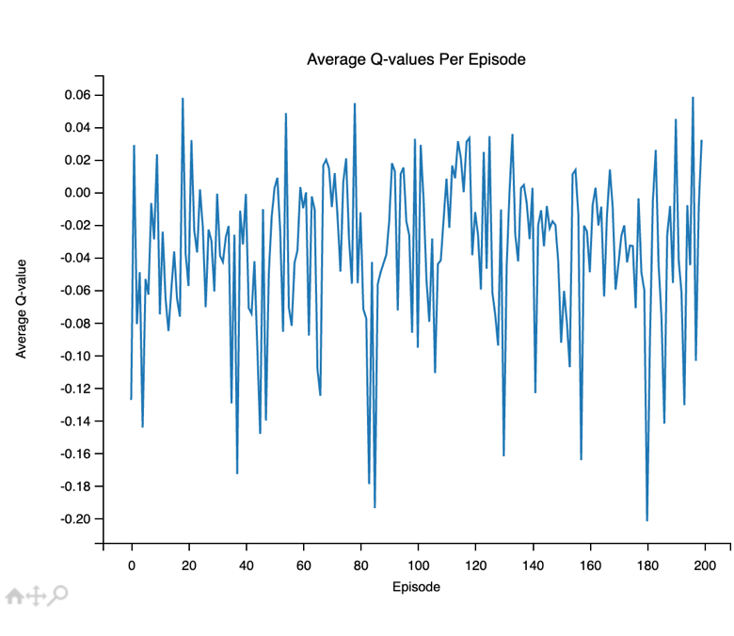
Fig 3. Plot of Average Q values per episode during reinforcement training phase

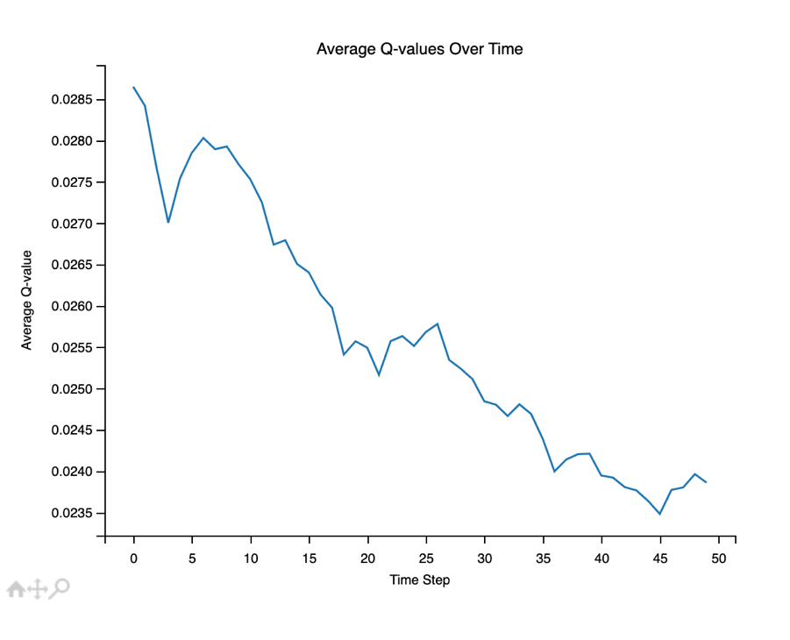
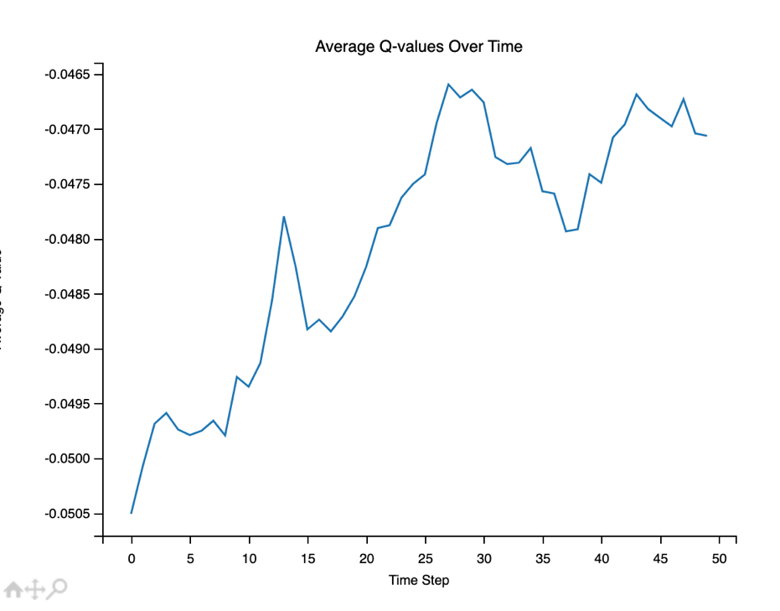
The "Average Q-values Per Episode" graph is a visualization that shows how the average Q-value changes over the course of each episode during the training of the reinforcement learning agent, as shown in Fig3. Q-values represent the expected future reward for taking a certain action in a certain state, considering future states as well. Therefore, the average Q-value per episode can be seen as a measure of how well the agent is learning to predict the future reward of its actions.At the start of the training, the agent has no knowledge about the environment, so it makes random decisions. This is reflected in the Q-values, which are initially low because the agent's predictions about future rewards are inaccurate.As the agent explores the environment and receives feedback in the form of rewards or penalties, it updates the Q-values using the Q-learning update rule. This allows the agent to improve its predictions about future rewards, which is reflected in the increasing average Q-value per episode.If the graph shows a steady increase, this indicates that the agent is consistently learning from its experiences and improving its policy over time. If the graph plateaus, this could mean that the agent has learned an optimal policy or that it is no longer improving and might be stuck in a suboptimal policy. However, it's important to note that a higher average Q-value does not always mean better performance. It's possible for an agent to overestimate the Q-values (a problem known as "over-optimism"), which can lead to suboptimal policies. Therefore, the "Average Q-values Per Episode" graph should be interpreted in conjunction with other performance metrics and visualizations (Kim and Yang, 2020).
Fig 4A. Plot of Average Q-values over time of the first program run
Fig 4B. Plot of Average Q-values over time of the second program run

The "Average Q-value Over Time" graph represents the evolution of expected future rewards, or Q-values, for taking certain actions in certain states as the agent learns from its environment.In the first execution (Fig 4A), an increase in Q-values over time was observed. This typically suggests that the agent is learning and improving its policy. The agent discovers actions that yield higher rewards and updates its Q-values to reflect this learning. This increasing trend in Q-values is a positive indication, suggesting successful learning from the agent's experiences and an effective adjustment of actions to maximize future rewards.Contrarily, the second execution (Fig 4B)showed a decrease in Q-values over time. This outcome could be interpreted in several ways. One possibility is that the agent might be exploring more at the beginning, taking random actions leading to inflated initial Q-values. As it begins to exploit its knowledge, taking actions it deems as the best, it might realize that the initial Q-values were overestimated, resulting in a decrease in Q-values. Another possibility is that the agent might be stuck in a suboptimal policy. If the agent consistently takes actions leading to low rewards, the Q-values will decrease, suggesting that the agent is not learning the optimal policy effectively. Lastly, the environment might be non-stationary, where the rewards for certain state-action pairs change over time. If the rewards are decreasing, the Q-values will decrease accordingly, reflecting the dynamic nature of the environment.

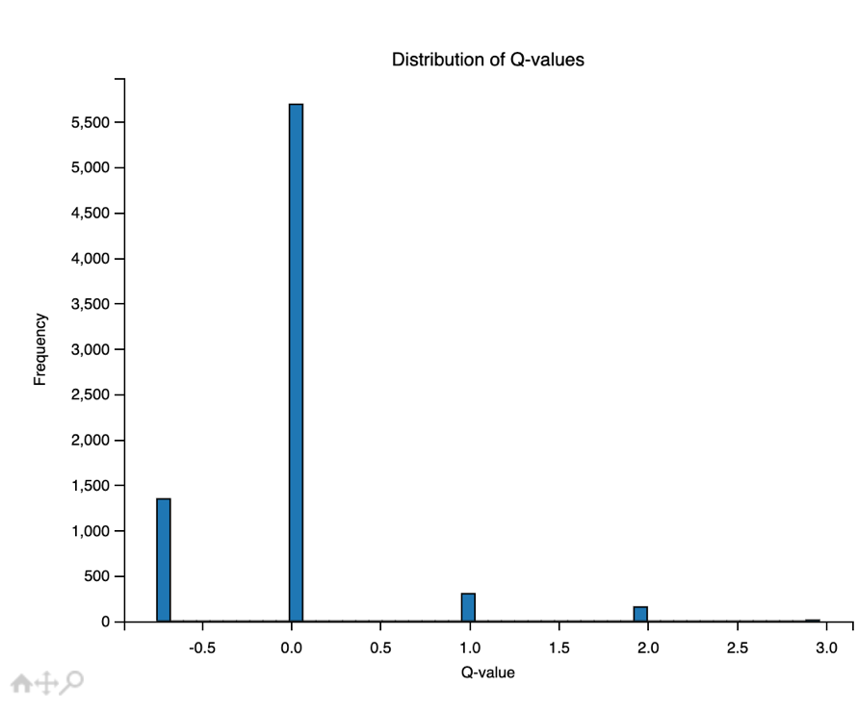
Fig 5. Plot of an histogram showing the distribution of Q values and their frequency densities.

The "Distribution of Q-values" graph is a histogram that shows the frequency of different Q-values at a certain point in time, as shown in Fig 5. Q-values represent the expected future reward for taking a certain action in a certain state, considering future states as well. A high frequency of zero values in your Q-value distribution could indicate that a large portion of the state-action space has not been explored during the training process. The width and skewness of the distribution can provide insights into the learning progress of the agent. A wide distribution spanning a large range indicates that the agent has learned to distinguish between good and bad actions. If the distribution is narrow and concentrated around a certain value, it means that the agent assigns similar Q-values to different actions in different states, which could be a sign that the agent is not learning effectively. Skewness towards high Q-values means that the agent is optimistic about the future rewards it can achieve, indicating good adaptation to the environment and learning to take actions that lead to high rewards. Conversely, skewness towards low Q-values could be a sign that the agent is struggling to adapt to the environment and often engages in actions that yield low rewards. If the distribution has a high frequency of zero values, it suggests that a large portion of the state-action space hasn't been explored. This could be due to insufficient training time, a low exploration rate, or an overly large state-action space. Exploration is a crucial part of reinforcement learning, as it allows the agent to accurately estimate Q-values and potentially find the optimal policy (Kim and Yang, 2020).

Discussion
Exploring the Impact of Parameters on System Behavior
Changing the parameters of the system can significantly affect the behavior of the system. Hence to gain a deeper understanding of the system, we can employ several strategies. First, adjusting parameters such as the number of boids, the size of the space, the weights for different behaviors, or learning-related parameters can significantly influence the behaviors and learning process of the system. For instance, the num_boids parameter controls the number of boid agents in the model, where an increase leads to more complex interactions and behaviors due to a larger flock size, and a decrease simplifies these dynamics. Similarly, the width and height parameters that control the spatial dimensions can affect the dispersion or concentration of flocks.
The weights in the BoidAgent class that control the importance of separation, alignment, and cohesion behaviors can significantly impact the overall behavior of the flock. For example, increasing the weight of separation could lead to more spread-out flocks, while increasing the weight of cohesion could result in more tightly-packed flocks.
Moreover, parameters like epsilon, epsilon_decay, and epsilon_min in the BoidAgent class control the exploration-exploitation trade-off in the Q-learning algorithm. Modifying these parameters will affect how quickly the boids learn and how they balance exploration (trying new actions) and exploitation (repeating actions that have worked well in the past).
Second, implementing a real-time visualization of the system can provide a more intuitive understanding of the flocking behavior. By observing the boids move and interact in real-time, we can gain insights into patterns and dynamics that might not be easily discernible from numerical data alone.
Third, the collected data, including the average position and velocity of the boids as well as each boid's Q-table, can be analyzed further for a more detailed understanding of the system's behavior. This could involve tracking the evolution of specific state-action pair Q-values over time or observing changes in the flock's average velocity as learning progresses.
Experimenting with integrated behaviors can also yield valuable insights. For instance, adding behaviors such as obstacle avoidance or predator evasion, or removing behaviors like cohesion, could significantly impact the flocking behavior and provide insights into the role and importance of these behaviors.
Finally, conducting longitudinal studies by running the simulation for a longer duration or across more episodes can shed light on the system's long-term behavior. We can determine whether the boids continue to learn and adapt their behavior over time or if they eventually reach a point of behavioral stability.
The effects of changing these parameters can be complex and non-linear, and they can interact with each other in unexpected ways. Therefore, a combination of parameter adjustment, visualization, data analysis, integrated behavior experimentation, and longitudinal studies can collectively enhance our understanding of the system dynamics, the boids' learning process, and the impact of different parameters and behaviors on the flocking behavior.

Possible Improvements, Evaluations for Robustness and Potential Applications
There are several ways to enhance and assess the robustness of the system, along with exploring potential other applications.
One of the examples are the study proposed by Vicsek (1995) which developed a model in which all agents move with the same speed hence no dynamics, and only follow an alignment rule. each agents positions are averaged and updated with its its nearest neighbours with noise introduced as well. In this study numerical simulations indicated the spontaneous development of coherent collective motion, resulting in the headings of all agents to converge to a common value (Vicsek et al., 1995).
Improvements can be made in several areas. Firstly, parameter tuning could optimize system performance. This includes adjusting the weights for separation, alignment, and cohesion, as well as the learning rate and the discount factor. Secondly, striking a better balance between exploration and exploitation could enhance the system's learning capability. More sophisticated methods than the epsilon-greedy approach, such as Upper Confidence Bound (UCB) or Thompson Sampling, could be used for this purpose. Finally, a more informative representation of the system's state could lead to better performance. For instance, features such as the distance to the nearest boid or the average velocity of nearby boids could be included, in addition to just the position, velocity, and acceleration of the boids (Agrawal and Goyal, 2012).

Additional Strategy for Improvement
In Q-learning, the action with the highest Q-value is typically chosen during the exploitation phase because it is expected to yield the highest reward. The Q-value is an estimate of the total reward that can be obtained from a state by taking an action and following the optimal policy thereafter. Therefore, choosing the action with the highest Q-value could be a way of maximizing the expected reward. However, we could a different stratergy where action with the highest Q-value is chosen. Hence, opting for a random choice from the entire range of potential actions and considering all Q values, not solely the maximum one, could enhance exploration while reducing exploitation.

Related Work
The presented papers by Sho Yamauchi, Hidenori Kawamura, Keiji Suzuki, and Bojan Jakimovski, Benjamin Meyer, Erik Maehle demonstrate the innovative application of nature-inspired mechanisms in technology. Yamauchi et al. present the Arbitrary Lattice Formation with Flocking (ALFF) algorithm for camera tracking systems, which draws on the principles of flocking behavior observed in the natural world. This aligns with the principles applied in our boids simulation, which could potentially enhance such tracking systems.
On the other hand, Jakimovski et al. introduce OSCAR, a self-reconfiguring hexapod robot that employs organically inspired approaches, including an innovative leg amputation mechanism. The self-adaptivity demonstrated in the boids simulation parallels OSCAR's autonomous adaptability, possibly providing valuable insights for designing more efficient self-reconfiguring robots. In a remarkable convergence, both works highlight the application of nature-inspired, decentralized control mechanisms for developing adaptive, efficient solutions. To make OSCAR's fault detection more adaptive to the environment, we could consider integrating principles from the Artificial Immune System (AIS) paradigm. This could lead to a Swarm Intelligence for Robot Reconfiguration (SIRR) method, where a flocking algorithm inspired by the boids simulation could be used for robot reconfiguration.Much like modular robots, which are built out of many identical functional parts that can function as a robust robot when combined and coordinated properly, the boids simulation demonstrates that the overall system functionality is not compromised even when using a decentralized approach. Moreover, the functionality of each individual agent is vital for the overall system, suggesting that the flocking algorithm could be extremely beneficial for the reconfiguration of a robot using the SIRR method ( Jakimovski, Meyer, and Maehle, 2009: Yamauchi, Kawamura, and Suzuki, 2014).

Conclusion
In conclusion, this study demonstrates the complexity and adaptability of boid behavior through a Q-learning based simulation model. By adjusting various parameters and behaviors, we observed diverse outcomes which provided valuable insights into the dynamics of flocking behavior and the learning process of the boids. The application of reinforcement learning in this agent-based model showcases its potential in understanding and predicting complex systems, particularly those that involve interaction and coordination among individual agents. This research areaopens up possibilities for further exploration and application in various technological fields, from enhancing tracking systems to improving the adaptability of self-reconfiguring robots.
In conclusion, while the study aimed to demonstrate the adaptivity of boid behavior through a Q-learning based simulation model, the results indicated that the boids were not effectively adapting as anticipated. Altering various parameters and behaviors could improve the outcomes of the learning process of the flocking behavior over time. The application of reinforcement learning in this agent-based model showed potential for understanding complex systems, but failed to conclusively prove a high level of adaptability on the part of the individual agents. These findings emphasize the unpredictable and complex nature of such systems and underline the necessity for further research in this area.

References
Agrawal, S. and Goyal, N., 2012, June. Analysis of thompson sampling for the multi-armed bandit problem. In Conference on learning theory (pp. 39-1). JMLR Workshop and Conference Proceedings.

Epstein, J.M. and Axtell, R., 1996. Growing artificial societies: social science from the bottom up. Brookings Institution Press.

Gulzar, M.M., Munawar, M., Khalil, J., Sibtain, D. and Ahmed, A., 2021, November. œ-boids consensus algorithm using adaptive flocking model. In 2021 4th International Conference on Computing & Information Sciences (ICCIS) (pp. 1-6). IEEE.

Hartman, C. and Benes, B., 2006. Autonomous boids. Computer Animation and Virtual Worlds, 17(3‐4), pp.199-206.
Jakimovski, B., Meyer, B. and Maehle, E., 2009, July. Self-reconfiguring hexapod robot OSCAR using organically inspired approaches and innovative robot leg amputation mechanism. In International Conference on Automation, Robotics and Control Systems, ARCS-09, Orlando, USA.
Kazil, J., Masad, D. and Crooks, A., 2020. Utilizing python for agent-based modeling: The mesa framework. In Social, Cultural, and Behavioral Modeling: 13th International Conference, SBP-BRiMS 2020, Washington, DC, USA, October 18–21, 2020, Proceedings 13 (pp. 308-317). Springer International Publishing.

Kim, J. and Yang, I., 2020, July. Hamilton-Jacobi-Bellman equations for Q-learning in continuous time. In Learning for Dynamics and Control (pp. 739-748). PMLR.
Reynolds, C.W., 1987, August. Flocks, herds and schools: A distributed behavioral model. In Proceedings of the 14th annual conference on Computer graphics and interactive techniques (pp. 25-34).

Reynolds, C. (1995) Boids, Boids (flocks, herds, and schools: A distributed behavioral model). Available at: https://www.red3d.com/cwr/boids/ (Accessed: 25 April 2024).
Vicsek, T., Czirók, A., Ben-Jacob, E., Cohen, I. and Shochet, O., 1995. Novel type of phase transition in a system of self-driven particles. Physical review letters, 75(6), p.1226.

Tanner, H.G., Jadbabaie, A. and Pappas, G.J., 2003. Stability of flocking motion. University of Pennsylvania,” Technical Report.

Yamauchi, S., Kawamura, H. and Suzuki, K., 2014. Arbitrary Lattice Formation with Flocking Algorithm Applied to Camera Tracking System. In Distributed Autonomous Robotic Systems: The 11th International Symposium (pp. 247-258). Springer Berlin Heidelberg.

Olfati-Saber, R., 2006. Flocking for multi-agent dynamic systems: Algorithms and theory. IEEE Transactions on automatic control, 51(3), pp.401-420.

Appendix
import mesa
import numpy as np
import random
from mesa.space import ContinuousSpace
from mesa.time import RandomActivation
from mesa.datacollection import DataCollector
import matplotlib.pyplot as plt

class BoidAgent(mesa.Agent):
def __init__(self, unique_id, model):
super().__init__(unique_id, model)
self.position = np.array([random.uniform(0, 1), random.uniform(0, 1)])
self.velocity = np.array([random.uniform(-1, 1), random.uniform(-1, 1)])
self.acceleration = np.array([random.uniform(-1, 1), random.uniform(-1, 1)]) # Changed from np.zeros(2)
self.weights = np.array([1.0, 1.0, 1.0]) # weights for separation, alignment, and cohesion
self.states= set()

self.epsilon = 1.0 # Initialize epsilon
self.epsilon_decay = 0.995 # Set the decay rate for epsilon
self.epsilon_min = 0.01 # Set the minimum value for epsilon
#initalise q-table
self.q_table = {}
# Initialize learning_rate
self.learning_rate = 0.5 # You can set this to any value between 0 and 1
self.discount_factor = 0.95 # You can set this to any value between 0 and 1

def choose_action(self, state):
# Convert the state to a tuple
state = tuple(state)

# Implement epsilon-greedy strategy
if random.uniform(0, 1) < self.epsilon:
# Choose a random action
action = random.choice(['separation', 'alignment', 'cohesion'])
else:
#check if the state is in the q-table
if state not in self.q_table:
# Add the state to the q-table
self.q_table[state] = {'separation': 0, 'alignment': 0, 'cohesion': 0}

# Choose a random action from the actions with the highest Q-value
max_q_value = max(self.q_table[state].values())
best_actions = [action for action, q_value in self.q_table[state].items() if q_value == max_q_value]
action = random.choice(best_actions)

# Decay epsilon
if self.epsilon > self.epsilon_min:
self.epsilon *= self.epsilon_decay

return action

def update_q_value(self, old_state, action, reward, new_state, alpha=0.5, gamma=0.95):
# Check if the old state is in the Q-table
if old_state not in self.q_table:
# If the old state is not in the Q-table, initialize it with zero Q-values for all actions
self.q_table[old_state] = {'separation': 0, 'alignment': 0, 'cohesion': 0}

# Implement Q-value update
old_q_value = self.q_table[old_state][action]
max_new_q_value = max(self.q_table[new_state].values())
self.q_table[old_state][action] = old_q_value + alpha * (reward + gamma * max_new_q_value - old_q_value)

def get_state(self):
state = (
tuple(self.position),
tuple(self.velocity),
tuple(self.acceleration)
)
self.states.add(state)
return state

def reward(self, state, action):
# Initialize reward
reward = 0

# Get all boids within a certain radius
nearby_boids = self.model.space.get_neighbors(self.position, 5, False)

# Reward the boid for staying close to the flock
if len(nearby_boids) > 0:
reward += 1

# Penalize the boid for collisions
for other in nearby_boids:
if np.linalg.norm(self.position - other.position) < 1: # assuming a collision if distance is less than 1
reward -= 5

# Add your logic here to calculate reward based on state and action
if action == 'separation':
# If the boid is too close to others, reward it for taking the 'separation' action
if np.linalg.norm(
self.position - state[0]) < 1: # assuming the state is too close if distance is less than 1
reward += 1
elif action == 'alignment':
# If the boid's velocity is different from the average, reward it for taking the 'alignment' action
if np.linalg.norm(self.velocity - state[1]) > 1: # assuming the state is misaligned if the difference in velocity is more than 1
reward += 1
elif action == 'cohesion':
# If the boid is too far from others, reward it for taking the 'cohesion' action
if np.linalg.norm(self.position - state[0]) > 5: # assuming the state is too far if distance is more than 5
reward += 1

# Reward for maintaining a moderate speed
speed = np.linalg.norm(self.velocity)
if 1 < speed < 2: # assuming moderate speed if speed is between 1 and 2
reward += 1
else:
# Penalize for moving too fast or too slow
reward -= 1

return reward

def update_weights(self, action):
# Update the weights based on the action
if action == 'separation':
self.weights[0] += 1
elif action == 'alignment':
self.weights[1] += 1
elif action == 'cohesion':
self.weights[2] += 1

def step(self):
# Get the current state
old_state = self.get_state()

# Choose an action
action = self.choose_action(old_state)

# Get the reward based on the current state and action
reward = self.reward(old_state, action)

# Get the new state after taking the action
new_state = self.get_state()

# Update the Q-value for the current state and action
self.update_q_value(old_state, action, reward, new_state)

if new_state not in self.q_table:
# If the new state is not in the Q-table, initialize it with zero Q-values for all actions
self.q_table[new_state] = {'separation': 0, 'alignment': 0, 'cohesion': 0}

# Calculate the maximum Q-value for the new state
max_new_state_q_value = max(self.q_table[new_state].values())

# Update the Q-value for the current state and action
self.q_table[old_state][action] = (1 - self.learning_rate) * self.q_table[old_state][action] + self.learning_rate * (
reward + self.discount_factor * max_new_state_q_value)

# Update the weights based on the action
self.update_weights(action)

# Get all boids within a certain radius
nearby_boids = self.model.space.get_neighbors(self.position, 5, False)

# Calculate the forces
separation_force = self.separation(nearby_boids, 1)
alignment_force = self.alignment(nearby_boids, 5)
cohesion_force = self.cohesion(nearby_boids, 5)

# Update the acceleration based on the forces
self.acceleration = self.weights[0] * separation_force + self.weights[1] * alignment_force + self.weights[
2] * cohesion_force

# Update the position and velocity based on the new acceleration
self.position += self.velocity
self.velocity += self.acceleration

#DEFINE THE RULES OF THE SYSTEM
def separation(self, boids, distance):
total = 0
steering = np.zeros(2, dtype=float)
for boid in boids:
if np.linalg.norm(self.position - boid.position) < distance:
steering += (self.position - boid.position)
total += 1
if total > 0:
steering /= total
return steering

def collision_avoidance(self, boids, min_distance):
total = 0
steering = np.array([0.0, 0.0])
for boid in boids:
distance = np.linalg.norm(self.position - boid.position)
if distance < min_distance:
steering += (self.position - boid.position)
total += 1
if total > 0:
steering /= total
return steering

def cohesion(self, boids, perception_radius):
total = 0
center_of_mass = np.array([0.0, 0.0])
for boid in boids:
distance = np.linalg.norm(self.position - boid.position)
if distance < perception_radius:
center_of_mass += boid.position
total += 1
if total > 0:
center_of_mass /= total
return center_of_mass - self.position
else:
return np.array([0.0, 0.0])

def alignment(self, boids, perception_radius):
total = 0
average_velocity = np.array([0.0, 0.0])
for boid in boids:
distance = np.linalg.norm(self.position - boid.position)
if distance < perception_radius:
average_velocity += boid.velocity
total += 1
if total > 0:
average_velocity /= total
return average_velocity - self.velocity
else:
return np.array([0.0, 0.0])

class BoidModel(mesa.Model):
def __init__(self, width, height, num_boids):
super().__init__()
self.width = width
self.height = height
self.num_boids = num_boids
self.space = ContinuousSpace(self.width, self.height, torus=False)
self.schedule = RandomActivation(self) # Create a schedule and add it to the model
self.q_values_over_time = []

self.cohesion = 0
self.alignment = 0
self.separation = 0
self.centering = 0

# Create boids
for i in range(self.num_boids):
boid = BoidAgent(i, self)
self.space.place_agent(boid, (self.random.uniform(0, self.width), self.random.uniform(0, self.height)))
self.schedule.add(boid) # Add boid to the schedule

self.datacollector = DataCollector(
model_reporters={
"AveragePosition": lambda m: np.mean([agent.position for agent in m.schedule.agents], axis=0),
"AverageVelocity": lambda m: np.mean([agent.velocity for agent in m.schedule.agents], axis=0),
"Cohesion": lambda m: m.cohesion,
"Alignment": lambda m: m.alignment,
"Separation": lambda m: m.separation,
"Centering": lambda m: m.centering
},
agent_reporters={
"QTable": lambda a: a.q_table # New agent reporter
}
)

def calculate_cohesion(self):
distances = [np.linalg.norm(agent1.position - agent2.position)
for agent1 in self.schedule.agents
for agent2 in self.schedule.agents
if agent1 != agent2]
self.cohesion = np.mean(distances)

def calculate_alignment(self):
velocities = [agent.velocity for agent in self.schedule.agents]
self.alignment = np.var(velocities)

def calculate_separation(self):
distances = [np.linalg.norm(agent1.position - agent2.position)
for agent1 in self.schedule.agents
for agent2 in self.schedule.agents
if agent1 != agent2]
self.separation = np.min(distances)

def calculate_centering(self):
positions = [agent.position for agent in self.schedule.agents]
self.centering = np.var(positions)

def step(self):
self.schedule.step()
self.datacollector.collect(self)
self.calculate_cohesion()
self.calculate_alignment()
self.calculate_separation()
self.calculate_centering()
self.q_values_over_time.append({agent.unique_id: agent.q_table for agent in self.schedule.agents})
self.states = set().union(*(agent.states for agent in self.schedule.agents))

model = BoidModel(width=100, height=100, num_boids=50)

for i in range(200): # Adjust the number of steps as needed
model.step()

# Get the collected data
data = model.datacollector.get_model_vars_dataframe()

# Plot the measures over time
plt.figure(figsize=(10, 10))
plt.plot(data['Cohesion'], label='Cohesion')
plt.plot(data['Alignment'], label='Alignment')
plt.plot(data['Separation'], label='Separation')
plt.plot(data['Centering'], label='Centering')
plt.title('Flock Stability Measures Over Time')
plt.xlabel('Time Step')
plt.ylabel('Measure')
plt.legend()
plt.show()

# Define the number of episodes
num_episodes = 200

# Initialize an empty list to store the average Q-values for each episode
average_q_values_per_episode = []

# Run the model for a certain number of episodes
for episode in range(num_episodes):
# Initialize the model
model = BoidModel(width=100, height=100, num_boids=50)

# Run the model for a certain number of steps
for i in range(50):
model.step()

# Initialize an empty list to store the Q-values for the current episode
current_q_values = []

# Iterate over all agents in the model's schedule
for agent in model.schedule.agents:
# Get all the Q-values for the current agent
q_values = agent.q_table

# For each state-action pair, add the Q-value to the list
for state, actions in q_values.items():
for action, q_value in actions.items():
current_q_values.append(q_value)

# Add the average Q-value for the current episode to the list
average_q_values_per_episode.append(sum(current_q_values) / len(current_q_values) if current_q_values else 0)

# Plot the average Q-values per episode
plt.plot(average_q_values_per_episode)

# Add a title and labels
plt.title('Average Q-values Per Episode')
plt.xlabel('Episode')
plt.ylabel('Average Q-value')

# Show the plot
plt.show()

##################
model = BoidModel(width=100, height=100, num_boids=50)

# Run the model for a certain number of steps
for i in range(50):
model.step()

# Initialize an empty list to store the Q-values
all_q_values = []

# Iterate over all agents in the model's schedule
for agent in model.schedule.agents:
# Get all the Q-values for the current agent
q_values = agent.q_table

# For each state-action pair, add the Q-value to the list
for state, actions in q_values.items():
for action, q_value in actions.items():
all_q_values.append(q_value)

# Create a histogram of the Q-values
plt.hist(all_q_values, bins=50, edgecolor='black')

# Add a title and labels
plt.title('Distribution of Q-values')
plt.xlabel('Q-value')
plt.ylabel('Frequency')

# Show the plot
plt.show()

# Initialize an empty list to store the Q-values at each time step
q_values_over_time = []

# Run the model for a certain number of steps
for i in range(50):
model.step()

# Initialize an empty list to store the Q-values for the current time step
current_q_values = []

# Iterate over all agents in the model's schedule
for agent in model.schedule.agents:
# Get all the Q-values for the current agent
q_values = agent.q_table

# For each state-action pair, add the Q-value to the list
for state, actions in q_values.items():
for action, q_value in actions.items():
current_q_values.append(q_value)

# Add the average Q-value for the current time step to the list
q_values_over_time.append(sum(current_q_values) / len(current_q_values) if current_q_values else 0)

# Plot the Q-values over time
plt.plot(q_values_over_time)

# Add a title and labels
plt.title('Average Q-values Over Time')
plt.xlabel('Time Step')
plt.ylabel('Average Q-value')

# Show the plot
plt.show()

